Partnership for the Assessment of Risks from Chemicals

# Training on *In silico* models and read-across

  
**Course Application Form**

This partnership has received funding from the European Union’s Horizon Europe research and innovation programme under Grant Agreement No 101057014.

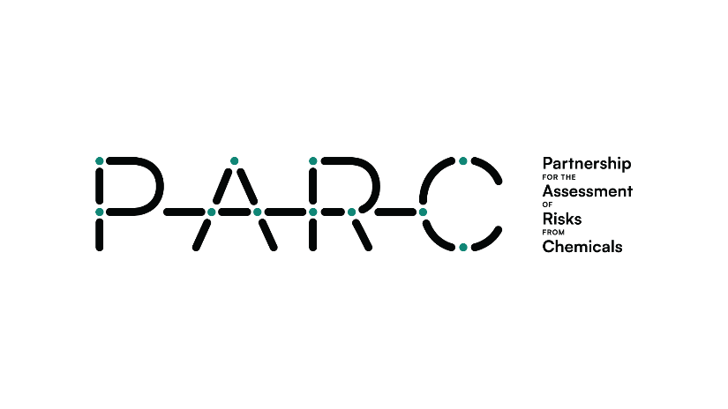

Use and Interpretation of the Results of *In Silico* Models and Read-across

Context: PARC is now organising an online training course on the “Use and interpretation of the results of *in silico* models and read-across”. This training course welcomes both PARC members and non-members. There are no registration fees.

To ensure the best possible fit for our training program, we kindly request some essential personal and professional details in this application form. This information will be used solely for trainee selection purposes. Anonymized data will also be used for PARC project reporting.

Data management: Data collected will be saved and stored for the duration of PARC project by the National Institute of Health (INSA), Portugal, and transferred only to the other organising institution (i.e. Istituto Mario Negri (IRFMN), Italy). Data management and handling will follow the General Data Protection Regulation (GDPR) of the EU (2016/679).

Deadline for application: **24.02.2025**

If you are unable to access the online application form ([here](https://survey-insa.min-saude.pt/redcap/surveys/?s=XKJEFAJX4K)), ensure you complete this file and send it to [carla.trindade@insa.min-saude.pt](mailto:carla.trindade@insa.min-saude.pt) before the indicated deadline.

In case of need, please contact Emilio Benfenati ([emilio.benfenati@marionegri.it](mailto:emilio.benfenati@marionegri.it)) and Carla Trindade Costa ([carla.trindade@insa.min-saude.pt](mailto:carla.trindade@insa.min-saude.pt)).

On behalf of the scientific coordination of the training course and Task 9.4 co-leaders,

Emilio Benfenati & Carla Trindade Costa

# Consent

1. Do you confirm that you have read and accept the information stated above?

Yes

No

# I. Personal Details

1. First name
2. Last name
3. Email address
4. Gender

Woman

Man

Non-binary

Other

Prefer not to answer

1. Age       years-old
2. Nationality

# II. Education

1. PhD

Yes. Indicate here area and year of graduation       (e.g. Public Health, 2010)

No

1. MSc

Yes. Indicate here area and year of graduation       (e.g. Toxicology, 2006)

No

1. BSc

Yes. Indicate here area and year of graduation       (e.g. Biology, 2004)

No

# III. Professional Activity

1. Current Affiliation (Institution, Department and Country)

1. Institution type *(select one option)*

Academia

R&D

Regulatory body or organisation

Authority/government agency

Business & Industry (including industry associations)

NGOs

Other. Please specify:

1. Position
2. Field(s) of work *(choose up to three options)*

Epidemiology  Toxicology

Nutrition  Microbiology

Chemical Sciences  Public Health

Social Sciences  Healthcare (e.g., medicine, nursing)

Risk/Health Impact assessment  Environmental Health

Data Management

Data science / Informatics (e.g., modelling, software / hardware development)

Other. Please specify:

Other. Please specify:

Other. Please specify:

1. Nº years of experience
2. Are you involved in PARC activities?

Yes. Please indicate in which WPs:

*(choose all that apply)*

WP1: Coordination and management

WP2: A common science-policy agenda

WP3: Synergies, collaborations and awareness

WP4: Monitoring and exposure

WP5: Hazard assessment

WP6: Innovation in regulatory risk assessment

WP7: FAIR data

WP8: Concepts and toolboxes

WP9: Building infrastructural and human capacities

No

# IV. Training Course

1. The first part of the course will take place on the morning of March 3rd. If there are more than 30 participants, an additional session will be scheduled for the afternoon. Please indicate your preferred session.

Morning

Afternoon

*Kindly note that while we will do our best to accommodate preferences, it may not be possible to fulfil all requests.*

1. The second part of the course will take place on March 4th and will include multiple sessions. Please select all the lectures you wish to attend.

Examples related to physico-chemical and environmental properties| Morning

Examples related to ecotoxicological properties| Morning

Examples related to mutagenicity and genotoxicity| Afternoon

Examples related to endocrine disruption| Afternoon

Examples of *in silico* models for cosmetic evaluation and replacement of risky substances| Afternoon

# V. Final Questions

1. How did you learn about this course?

*(e.g. PARC website, social media, internal communication in my institution/university, etc.)*

1. Do you certify the accuracy of all the information provided above?

Yes

No

*---- End of the form----*

Thank you for your interest!